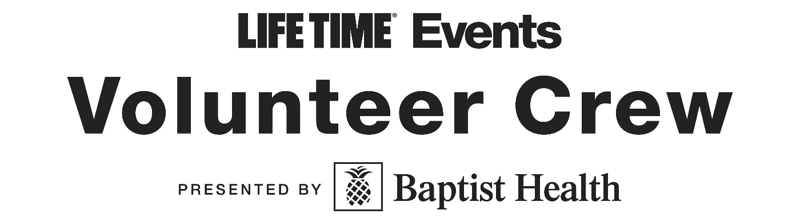

Rewards Program

Welcome to the NEW Life Time Events Volunteer Crew presented by Baptist Health Rewards Program!
We are truly thankful for the time and effort our volunteers put in at each of our Life Time Miami races. This new rewards program helps us show our gratitude for our valuable volunteers. Hit milestones throughout the year and earn rewards along the way!

Volunteer Sign-Up & Tracking
All volunteers must register through GivePulse for each event of choice, where shifts, hours, and roles are recorded and tiered incentives are automatically tracked. Volunteers are responsible for checking in/getting hours signed off by the Volunteer Coordinator at each event for hours to count.

Eligible Volunteering Opportunities
- Pre-Race Expo/Packet Pickup
- Race Day
- Set-up & Tear-down Crews
- Water Stations, Start/Finish Zones, Medical Tent Support
- Info Booths, Expo Greeters
- Volunteer Leadership Roles (Zone Captains, Team Leads) and more!

Review the Milestone Tracker on the next page to plan out your volunteering schedule and earn some awesome perks!
Milestone Tracker
Tier | Hours Required | Perks | Stipulations
Supporter | 4+ hours | Volunteer Shirt/Goodies  Digital Certificate of Appreciation  Post-race Thank You Email | Entire shift completed
Advocate | 10+ hours | - All Supporter Perks -  Bonus swag item (from Marketing/Sponsor) | Entire shift(s) completed
Champion | 15+ hours | - All Advocate Perks –  Priority, comp registration for next year's Miami Marathon (or race of choice) | 15+ hours within the year  OR  Complete 3 entire shifts during Miami Marathon race weekend
Legend | 20+ hours | - All Champion Perks-  Priority, comp VIP entry into the following year’s Miami Marathon or Half  Recognition on event website/social/newsletter | Entire shift(s) completed

IMPORTANT NOTABLES
Eligible Life Time Events include the Miami Marathon & Half / Tropical 5K, 305 Half Marathon & 5K and Turkey Trot Miami 5K/10K. The program runs within the calendar year only. Be sure to sign up for your shifts with the same name/contact information and check in/get your hours signed off at each event to make sure your time counts. Gifts earned may be picked up from the Volunteer booth at the race where your milestone achievement will be met; digital/race entry rewards will be sent via email.

We can’t wait to welcome you to join our crew this race season!

